DEPARTMENTAL STORE MANAGEMENT SYSTEM SOFTWARE ENGINEERING PROJECT REPORT

B.Sc.(H)ComputerSCIENCE



Submitted By-:

|  |  |  |  |
| --- | --- | --- | --- |
| PRASHANT KUMAR MISHRA | SAGAR KASHYAP | YASH CHAUDHARY | RAJAT DESHWAL |

Department of Computer Science

Keshav Mahavidyalaya

University of Delhi

**Acknowledgement**

Apart from the efforts of team, the success of any project depends largely on the encouragement and guidelines of many others. We take this opportunity to express our gratitude to the people who have been instrumental in the successful completion of this project.

The completion of any inter-disciplinary project depends upon cooperation, and combined efforts of several sources of knowledge.

We are eternally grateful to our teacher **Dr. Sumit Aggarwal** for his even willing essto give us valuable advice and direction under whom we executed this project. His constant guidance and willing essto share his vast knowledge made usunderstand this project and its manifestation in great depths and helped us to complete the assigned tasks.

# Certificate

This is to certify that Software Engineering project report entitled departmental store management System” is the work carried out by **prashant kumar mishra , sagar kashyap,yash chaudhary,rajat deshwal** students of BSc(H) Computer Science IV semester ,KeshavMahavidyalaya ,University of Delhi under the supervision of **Dr. Sumit Aggarwal.**

This report has not been submitted to any other organization/institution for the awardoranyotherdegree/diploma.

Table of Contents

CHAPTER 1: INTRODUCTION

1.1 Review of current system business operation

1.2 Motivation

1.3 Goal of our Project

1.4 Problem Analysis and Methodology

1.5 Objectives

CHAPTER 2: LITERATURE REVIEW

2.1 What is Departmental store management system (DSMS)?

2.2 Reasons Why You Need DSM Software

2.3 Benefits of Using a DSM System

2.4 DSM Features :

CHAPTER 3: SYSTEM ANALYSIS

3.1 Requirement Analysis:

3.2 Software Requirement Specification:

3.3 Interface Requirement:

3.4 SRS Specification

CHAPTER 4: SYSTEM design and estimations

4.1 dfd diagrams

4.2 data dictionary

4.3 erd diagrams

4.4size estimation functional point analysis

4.5 cost estimation by cocomo 2 model

4.6 User Interface Design

4.6.1 Login

4.6.2 Home

4.6.3 Adding Product Brands

4.6.4 Product List

4.6.5 Add Product

4.6.6 Categorize List

4.6.7 Supplier Details

4.6.8 Customer Details

4.6.9 Stock List

4.6.10 Sales

4.6.11 After Sales Completion Terminal to Print Invoice

4.6.12 Report

4.6.13 Account Details

4.6.14 Configuration

4.7 Gantt Chart

4.8 risk management

CHAPTER 5: DEVELOPMENT AND IMPLEMENTATION

5.1 Project overview

5.2 DSMS (Departmental Store Management System) terminal.

5.3 Project outputs:

5. 4 Resource Allocation:

CHAPTER 6: CONCLUSION AND summary

REFERENCES 50

Chapter 1 :INTRODUCTION

The Departmental Store Management System (DSMS) is a comprehensive solution that encompasses hardware and software to manage both front-end and back-end operations of a business. It is a collection of protocols that co-ordinates the actions of multiple processes on a network to enable transactions and manage inventory.

Our DSMS is designed to offer a range of benefits to retailers, such as the ability to connect remote users with remote resources in an open and scalable way, larger and more powerful capabilities than a traditional inventory system, and the ability to synchronize data across multiple stores.

1.1 Review of current system business operation

Modern inventory software programs allow businesses to track usage, monitor changes in unit costs, calculate reorder points, and analyze inventory levels on an item-by-item basis. With DSMS software, retailers can even control inventory right at the cash register, recording each sale as it happens to keep inventory records up-to-date.

In addition to inventory management, DSMS software provides retailers with access to a wealth of sales data. By running reports based on this information, retailers can make better decisions about ordering and merchandising, analyze sales data to adjust purchasing decisions for seasonal trends, and integrate bar-code scanners and credit card authorization ability with the DSM system to improve pricing accuracy.

1.2 Motivation

DSMS systems, like those commonly found in retail establishments, feature complex arrangements of hardware, software, and network connections. These systems rely on predictable operation, and any number of problems can arise when hardware, software, or users do not perform as expected.

As a result, we developed our DSMS system to provide retailers with a reliable, real-time solution that works offline and online, even if the internet goes down. Our system automatically synchronizes with other terminals and provides up-to-date backups, making it a reliable choice for retailers of all sizes.

1.3 Goal of our Project

Our DSMS system is a web-based or mobile solution that can be used on multiple platforms, including mobile phones, tablets, and PCs. It includes a range of features designed to make running a retail business easier, such as inventory control, customer history, customizable reporting, and the ability to integrate multiple data sources into a single database.

Our system is mobile-friendly, allowing retailers to operate and view store details from their mobile phones. We also offer domain and hosting services to match a retailer's brand, and we provide an online store feature that enables retailers to quickly get their products online with just one click.

Our DSMS system is perfect for retail stores of all kinds, including fashion boutiques, home and lifestyle stores, health and beauty retailers, sports and outdoors stores, food and drink establishments, coffee shops, computer shops, bike shops, and many more.

1.4 Problem Analysis and Methodology

From the user's perspective, the problem with traditional retail systems is that branches and their associated systems function independently, making it difficult to keep track of changes made to local databases. To solve this problem, a distributed application is needed that can send objects from one application to another, making it easy to monitor the progress of the company and employees.

To address this problem, we used the Asail Methodology to analyze the requirements from the developer's perspective. We began by identifying possible challenges and developing alternative solutions. We then implemented our system using Bootstrap, CSS 3, Jquery, Ajax, PHP 7, MySQL, and the Codeigniter 3 framework, which are all open source applications.

1.5 Objectives

Our DSMS system provides businesses with the ability to computerize, systematize, and correlate retail information. Unlike traditional cash registers, which have limited information collection capacity, our system can gather, store, and return

Chapter 2: BACKGROUND STUDY

DSMS stands for Departmental Store Management System. This is a system that is used throughout the restaurant and retail industry. This computerized system allows business owners to track sales, cash flow, food inventory and can help simplify your bookkeeping enormously.

2.1 What is Departmental store management system (DSMS)?

Departmental Store Management Systems (DSMS) are computerized systems that are widely used in various industries for managing retail operations. They provide a wide range of functions, from tracking sales and inventory to managing customer data and employee records. DSMS are typically used in retail stores, supermarkets, departmental stores, restaurants, and other businesses where transactions take place.

DSMS consists of both hardware and software components. The hardware components include electronic cash registers, barcode scanners, touch-screen displays, receipt printers, scales, and pole displays. The software components include point-of-sale (POS) software, inventory management software, customer relationship management (CRM) software, and employee management software.

DSMS offer several benefits to businesses, including improved accuracy in inventory management, better customer service, and increased efficiency in operations. They can help businesses track sales and inventory in real-time, making it easier to identify which products are selling well and which are not. This information can be used to make informed decisions about stocking and pricing products, which can ultimately increase profitability.

DSMS can also help businesses improve customer service by providing a more personalized shopping experience. With access to customer data, businesses can tailor their offerings to specific customers and provide personalized recommendations. They can also use customer data to send targeted promotions and marketing campaigns, which can increase customer loyalty and retention.

Employee management is another key aspect of DSMS. By providing tools for tracking employee hours and performance, businesses can optimize staffing levels and ensure that employees are meeting performance goals. This can lead to increased productivity, better customer service, and higher overall profitability.

In conclusion, DSMS are essential tools for managing retail operations in today's digital age. They offer a range of benefits, including improved accuracy in inventory management, better customer service, and increased efficiency in operations. With the right DSMS in place, businesses can optimize their operations and increase profitability in the long run.

2.2 Reasons Why You Need DSM Software

A reliable and effective Departmental Store Management System (DSMS) is a valuable asset for any retail business. It can function like an expert team working behind the scenes, ensuring that all processes are running efficiently and smoothly. In the competitive landscape of the retail industry, having a DSMS is crucial for staying ahead of the competition. Here are some reasons why:

• Optimal Inventory Management

• Improved Customer Service

• Enhanced EfficiencyBetter Sales Tracking

• Streamlined Employee Management

In summary, a dependable DSMS is critical for operating a prosperous retail business. It improves inventory management, enhances customer service, streamlines operations, tracks sales data, and optimizes employee management. Utilizing a DSMS effectively helps businesses remain competitive and grow in the long term. you need a DSM system to help you run your business the right way here’s why

2.2.1 Quick and Accurate Sales

Sales are the backbone of any retail business. A DSM system ensures that each transaction is processed efficiently and accurately, reducing errors and increasing customer satisfaction. The system allows you to streamline the sales process by automating tasks such as inventory checks, pricing, and payment processing, saving you time and increasing sales.

2.2.2: Inventory Control

Effective inventory management is vital to the success of any retail business. A DSM system helps you keep track of your inventory by providing accurate real-time data on stock levels, sales, and customer demand. With this information, you can make informed decisions about which products to stock, when to reorder, and how much to order, thereby optimizing your inventory levels, reducing wastage, and increasing profitability.

2.2.3: Know Your Customers Understanding

your customers is critical to delivering personalized and exceptional customer experiences. A DSM system helps you build customer profiles and track their purchasing behavior, preferences, and needs. By analyzing this data, you can identify loyal customers, high-spending customers, and customers with unique requirements, enabling you to tailor your product offerings and marketing efforts accordingly.

2.2.4 Data-Driven Decision Making

To stay ahead in a highly competitive retail environment, you need to make informed decisions based on accurate data. A DSM system provides real-time insights into your sales, inventory, and customer data, allowing you to identify trends, patterns, and opportunities. With this information, you can make data-driven decisions about pricing, promotions, product selection, and marketing strategies, maximizing your profitability and staying ahead of the competition.

2.2.5 Time-Saving

Benefits Running a retail business involves a lot of manual tasks, such as pricing, inventory checks, and sales processing. A DSM system automates many of these tasks, reducing the amount of time and effort required to manage your store. The system enables you to generate reports, analyze data, and perform tasks quickly and accurately, freeing up your time to focus on other critical aspects of your business.

2.2.6 Bonus Vendor Integration

Vendor integration is an essential feature of modern DSM systems. It streamlines the purchasing process by enabling you to communicate with your vendors and suppliers directly. You can check the availability of products, place orders, and track deliveries seamlessly, reducing manual errors and saving time. By integrating with your vendors, you can also negotiate better prices and payment terms, further improving your profitability.

2.3 Benefits of Using a DSM System

A DSM system can provide a wide range of benefits to your business, improving efficiency and profitability in different areas of operation. Here are some key benefits, organized by category:

2.3.1 Inventory:

A Departmental Store Management System (DSM) helps you maintain an accurate count of your inventory by categorizing items into different levels for easy tracking and sorting. This ensures that you always have the right amount of stock on hand and reduces the risk of overstocking or understocking. Additionally, DSM systems can track suppliers, substitutes, aliases, and parent relationships, allowing you to manage your inventory more efficiently.

2.3.2 Purchasing:

DSM systems enable you to generate purchase orders quickly and efficiently, helping you replenish your stock as needed. This can result in lower vendor costs, as DSM systems can help you negotiate better prices based on historical purchasing data. By tracking purchase orders by order date, receive date, and cancel date, you can take the appropriate action on your open orders and maintain a healthy inventory level.

2.3.3 Departmental Store Management:

DSM systems help reduce pricing errors and speed up checkouts, ensuring a better shopping experience for your customers. By automating the lookup and selling process, DSM systems can apply pre-set sales, quantity discounts, and preferred price levels, streamlining the sales process. DSM systems also support multiple tender transactions, including cash, check, and credit card, making it easier for customers to complete their purchases.

2.3.4 Customer Relationship Management (CRM):

DSM systems allow you to keep a complete profile of every customer who has shopped in your store, including demographics, preferences, and purchase history. This information can be used to target market and send promotions to customers based on their purchasing history or other specific preferences, resulting in better customer engagement and loyalty.

2.3.5 Reports and Analysis:

DSM systems provide detailed reports and analysis that allow you to identify sales trends, review top performer reports for cashiers, salespersons, and customers, and export data into various formats. This can help you make informed decisions based on reliable data and ensure the continued success of your business.

2.4 DSM Features :

The Departmental Store Management System (DSM) has various features to manage the store efficiently. These features include:

• Login for Admin/Sales person: The DSM software allows both admin and salesperson to log in.

• Add New Salesperson: This feature enables the addition of a new user for selling products. The salesperson details include First Name, Last Name, Phone Number, Email, Additional Info, Password, and Verify Password.

• Delete Salesperson: The admin can delete a salesperson.

• Buy Product: Customers can buy products from Agora cosmetic and supermarket.

• Pay Bill: Customers can pay the bill for the products they have purchased.

• Sales Register: Salespersons must be registered to sell products.

• Sales Summary: The system maintains customer details, sales details, and payment details to generate a sales summary.

• Discounts for Cash: Customers can get discounts on products if they pay in cash.

• Customer Details: The system maintains customer name and address.

• Sales Details: The system maintains details such as amount, VAT, and total amount.

• Auto Product VAT: The system calculates and adds the VAT for the product.

• Payment Details: The system maintains cash and change details.

• Print Sales Reports: Salespersons can print sales reports.

• Delivery Receipts: Salespersons provide delivery receipts to customers.

• Product Inventory: The system maintains an inventory of products.

• Print Product Inventory: Salespersons can print a list of products in the inventory.

• Add Product: Salespersons can add new products to the inventory. The product details include Item Code, Item Description, Price, Discount, and Tax.

• Search Product: Salespersons can search for products in the stock.

• Edit Product: Salespersons can edit the product details such as Item Code, Item Description, Price, Discount, and Tax.

• Update Product: Salespersons can update the product details such as Item Code, Item Description, Price, Discount, and Tax.

• Delete Product: Salespersons can delete a product from the inventory.

• Generate Barcode: Salespersons can create a barcode for a product. The barcode details include Number of Code, Data, Output, and Print.

• Print Barcode Labels: Salespersons can print random barcode labels.

• Barcode Scanner: Salespersons can scan the barcode to ensure the integrity of the product.

• Refunds Products: The system stores the returned products in stock and updates the funds. The details maintained include Quantity, Item, Description, Unit Value, Discount, Tax, and Line Total Tk.

• Refunds and Sales Transactions: The system maintains information about the transaction after modifying the refund and sales. The details maintained include Date, Transaction, Salesperson, Payment Method, and Amount.

• Refund and Sales Transactions Report: The system generates a report on refund and sales transactions. The details maintained include Date, Transaction Ref, Salesperson, Payment Methods, and Amount.

• Daily/Weekly/Monthly/Yearly Reports: The system generates delivery date reports. The details maintained include Transaction and Stock Report.

• Print Daily/Weekly/Monthly/Yearly Reports: Salespersons can print daily, weekly, monthly, and yearly product sell reports.

Chapter 3 : SOFTWARE REQUIREMENT ANALYSIS

A software requirement is a field within software engineering that deals with establishing the needs of stakeholders that are to be solved by software. The IEEE Standard Glossary of Software Engineering Terminology defines requirements.

3.1 Requirement Analysis:

The Departmental Store Management System Requirements provides high-level of functional requirements. The functions of the DSM system are discussed below. Admin can directly login this system but the sales person used to register to login this system

* Admin
* Sales Person

Admin can do all activities in this system and the seal person, who sells product, Inventory product, seals reports create etc.

3.2 Software Requirement Specification:

Elements of the DSM Supplementary Specification:

* Documentation (user, installation, administration) and help
* licensing and other legal concerns
* Packaging
* Standards (technical, safety, quality)
* Physical environment concerns (for example, heat or vibration)
* Operational concerns (for example, how do errors get handled, or how often should
* backups be done?) Application-specific domain rules information in domains of interest (for example, what is the entire cycle of credit payment handling?)

3.2.1 SRS Scopes:

In recording the purchases made by customers, the following information are stored:

1. A unique transaction number assigned to every transaction,
2. The name of the customer
3. The name of the waiter
4. The items purchased and their prices
5. The date and time of the transaction
6. Discounts applied to the transaction (if any)
7. The total price of all the items bought or ordered after applying the discounts (if any).

For the database of items, the system will only store information about the items offered in the lounge. Data regarding the number of stock for each item is not covered since an inventory system is no longer in our scope. The following information are stored for each item in the database:

1. The unique product identification number
2. The product name
3. Item type
4. Category
5. The price the item was bought and
6. The selling price.

The item type is either Food or Drinks. The category may be any one of the followings: appetizer, chef’s special, noodles, starters, sandwich, sizzler, seafood, for Food itemtype; Cocktail, beer, liquor, shooters, on-the rocks, beverages, fruit shakes, for Drinks item-type.

3.2.2 SRS Assumption Dependencies:

Requirements analysis is usually the first phase of large-scale software development project. It is undertaken after a feasibility study has been performed to define the precise costs and benefits of a software system. The purpose of this phase is to identify and document the exact requirements for the system. The customer, the developer, a marketing organization or any combination of the three may perform such study. In cases where the requirements are not clear e.g., for a system that is never been defined, more interaction is required between the user and the developer. The requirements at this stage are in end-user terms.

Functional Requirement:

In Software engineering and systems engineering, a functional requirement defines a function of a system or its component. A function is described as a set of inputs, the behavior, and outputs. Functional requirements may be calculations, technical details, data manipulation and processing and other specific functionality that define what a system is supposed to accomplish. Behavioral requirements describing all the cases where the system uses the functional requirements are captured in use cases. Functional requirements are supported by nonfunctional requirements, which impose constraints on the design or implementation. Functional requirements are-

* Login
  + Simple two step login system
    - Admin Login
    - Sales person Login
* Administrator Dashboard
  + Admin can control whole system easily
  + Admin can add/delete sales person, Edit, update, delete, generate barcode etc.
  + Admin show payment option.
* Sales person Role:
  + Sell Products
  + Stock Products
  + Delivery Receipt
  + Payment Process
  + Accept Refunds Products
* Payment process
  + Only Cash Payments
  + Paid Vat
  + Get Discounts
* Barcode
  + Generate Barcode
  + Print Barcode Level
  + Barcode Scanner
* Refunds Process
  + Accept Refund Products
  + Cash back
* Reports Module
  + View Sales Reports
  + View Transaction Reports
  + View Refunds Reports
  + Daily/Weekly/Monthly/Yearly Reports
* Database

3.2.4 Non Functional Requirement:

In systems engineering and requirements engineering, a non-functional requirement is a requirement that specifies criteria that can be used to judge the operation of a system, rather than specific behaviors. They are contrasted with functional requirements that define specific behavior or functions. The plan for implementing functional requirements is detailed in the system design. The plan for implementing non-functional requirements is detailed in the system architecture, because they are usually Architecturally Significant Requirements.

3.2.4.1 Reliability

The following requirements describe the expected reliability of the Operational Interface

* The Operational Interface shall have a Mean Time Between Failures of no less⎫ than 17 days

3.2.4.2 Availability

The following requirements indicate the expected availability of the Operational Interface.

* The system shall be available 99.5% of the time⎫

3.2.4.3 Security

The software system needs a robust security mechanism in place so that unauthorized users are not allowed access to Departmental store management system. All users of the system must be uniquely identified. This could be done by using a user name and associated password scheme that would authenticate and authorize the user access to the system and, if applicable, grant the user access to restricted or controlled Departmental store management system. If a user cannot be identified, he/she will be given “anonymous” access with read-only capabilities. In order to monitor all past access to the system, all attempts to access the system must be logged.

* All users of the system shall login using some form of unique identification (e.g.,⎫ username and password)
* All login attempts shall be done so in a secure manner (e.g., encrypted passwords)⎫
* Each user shall either be trusted or not trusted.⎫

3.2.4.4 Maintainability

The following requirements increase the maintainability of the Operational Interface software.

* All source code and development related documents shall be controlled under a version⎫ control system
* All source code shall adhere to an agreed upon and well-defined set of coding standards⎫ for each development language used.
* A standard naming convention for classes, variables and packages shall be agreed upon⎫ and adhered to.

3.2.4.5 Portability

* Hardware
* Operating Systems

Since the software must run on several popular hardware platforms and the goal is to achieve a Reasonable level of platform independence. The system shall be compatible with the Microsoft Windows Operating System (Vista, Windows 7/8/10, XP or greater).

3.2.4.6 Usability

The system’s user interface intuitive, easy to use and provide an overall positive user experience.

3.3 Interface Requirement:

In computing, an interface is a shared boundary across which two separate components of a computer system exchange information. The exchange can be between software, computer hardware, peripheral devices, humans and combinations of these. Some computer hardware devices, such as a touchscreen, can both send and receive data through the interface, while others such as a mouse or microphone may only provide an interface to send data to a given system.

3.3.1 User Interfaces

* Login Screen
* Home Screen
* Product Inventory Details
* Add Products Page
* Refunds Product Page

3.3.2 Hardware Interfaces

* Server Configuration: Minimum 2GB Hard Disk
* P-III processor or equivalent
* Ram 512 MB
* Windows with Apache preloaded.
* Client Configuration

3.3.3 Software Interfaces

* Operating system =windowsnt11-windows xp
* Language = PHP
* Database = MYSQL

.3.4 Communications Interfaces

Communications interfaces can be provided through e-mail, web browser, network server communications protocols, electronic forms, and so on. For this we can use communication standards such as FTP or HTTP to provide security using encryption algorithms and synchronization mechanisms.

3.4 SRS Specification

A software requirements specification describes the essential behavior of a software. Content of the SRS Specification is given in Table 3.4

Table 3.4: SRS Specification

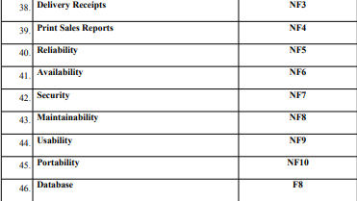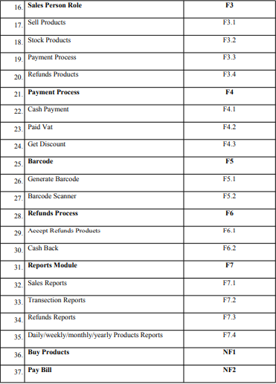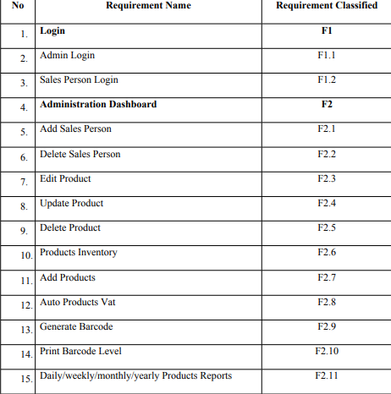

chapter 4 :SYSTEM DESIGN AND ESIMATIONS

Before developing a system we have to design our system like how Use case of our system. Data Flow Diagram (DFD) provides a view of how the system or business flows that able to increase the efficiency and effectiveness to achieve system objectives

4.1.1 Level 0 dfd

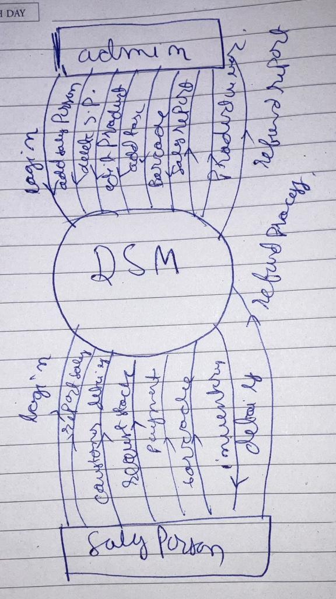

4.1.1:Level 1 dfd

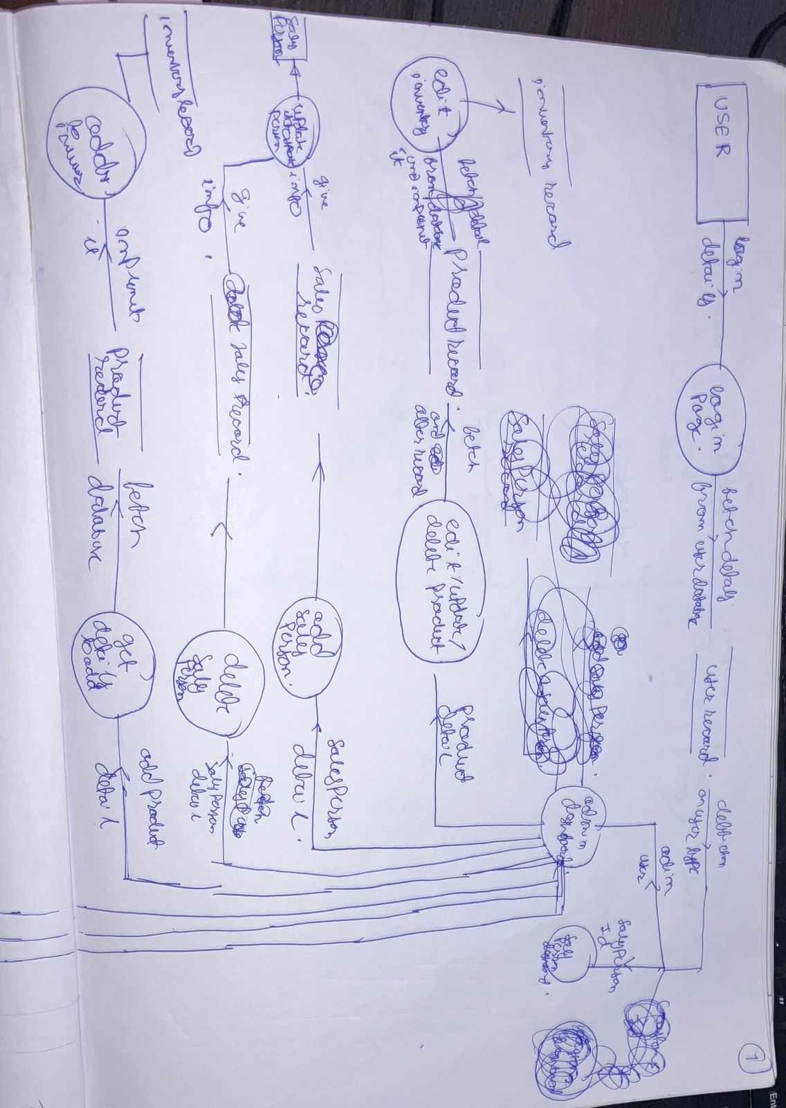

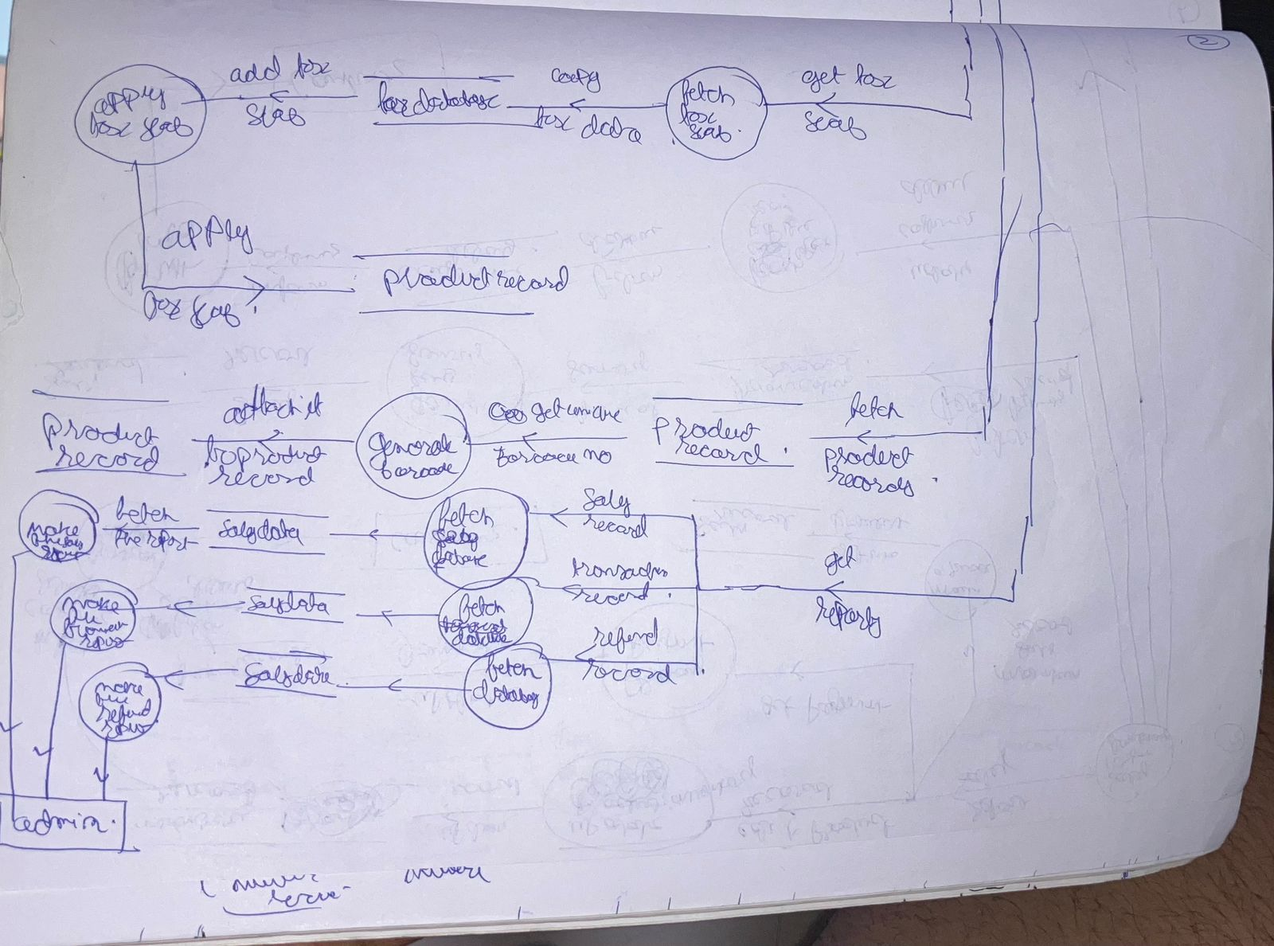

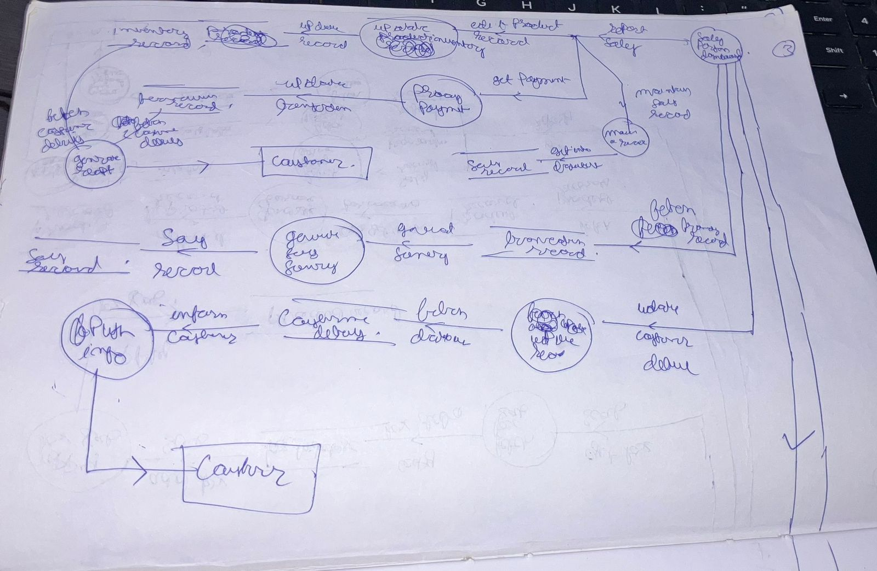

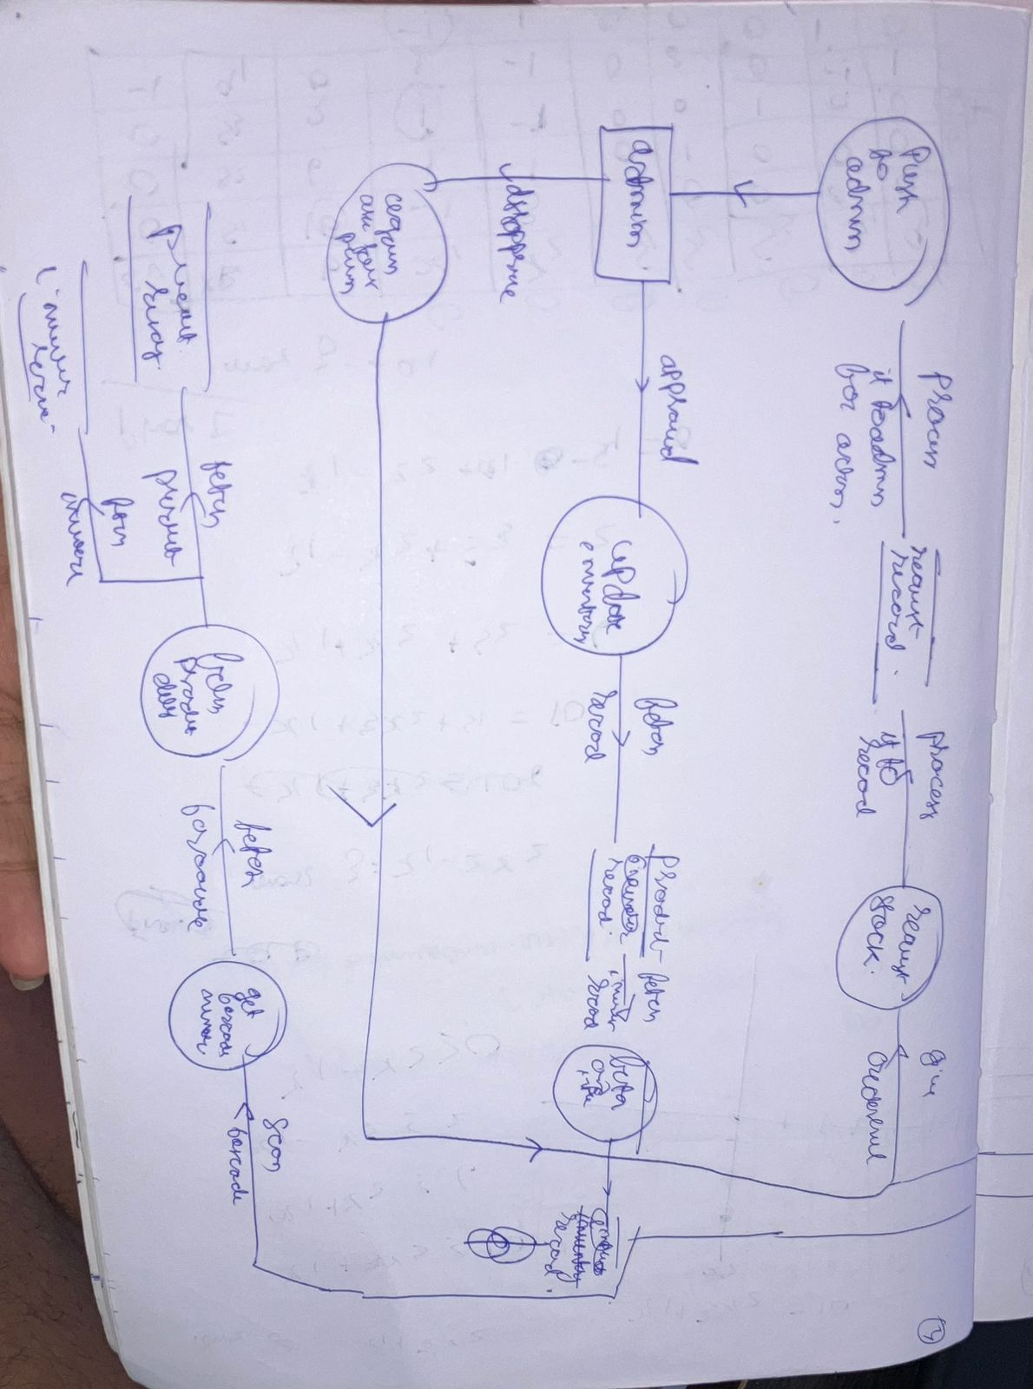

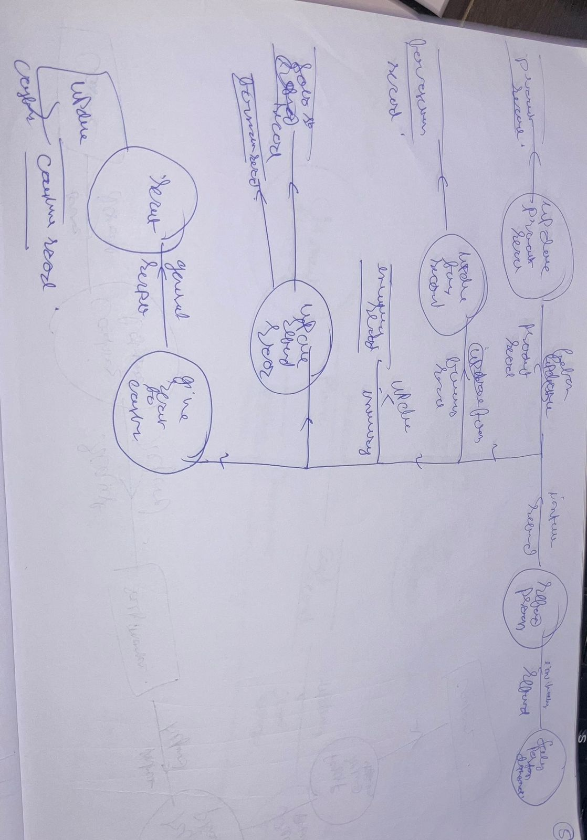

4.2:Data dictionary

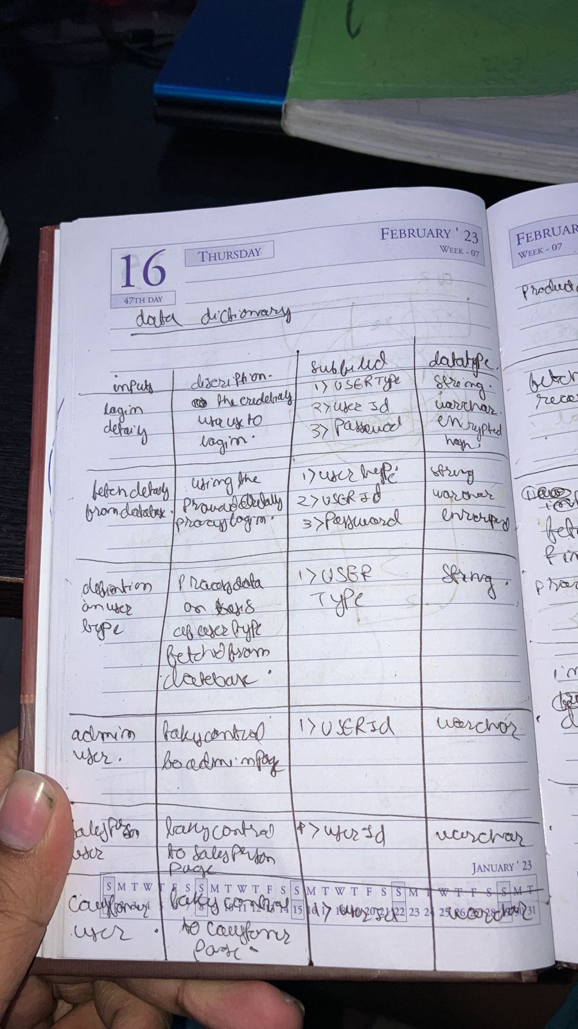

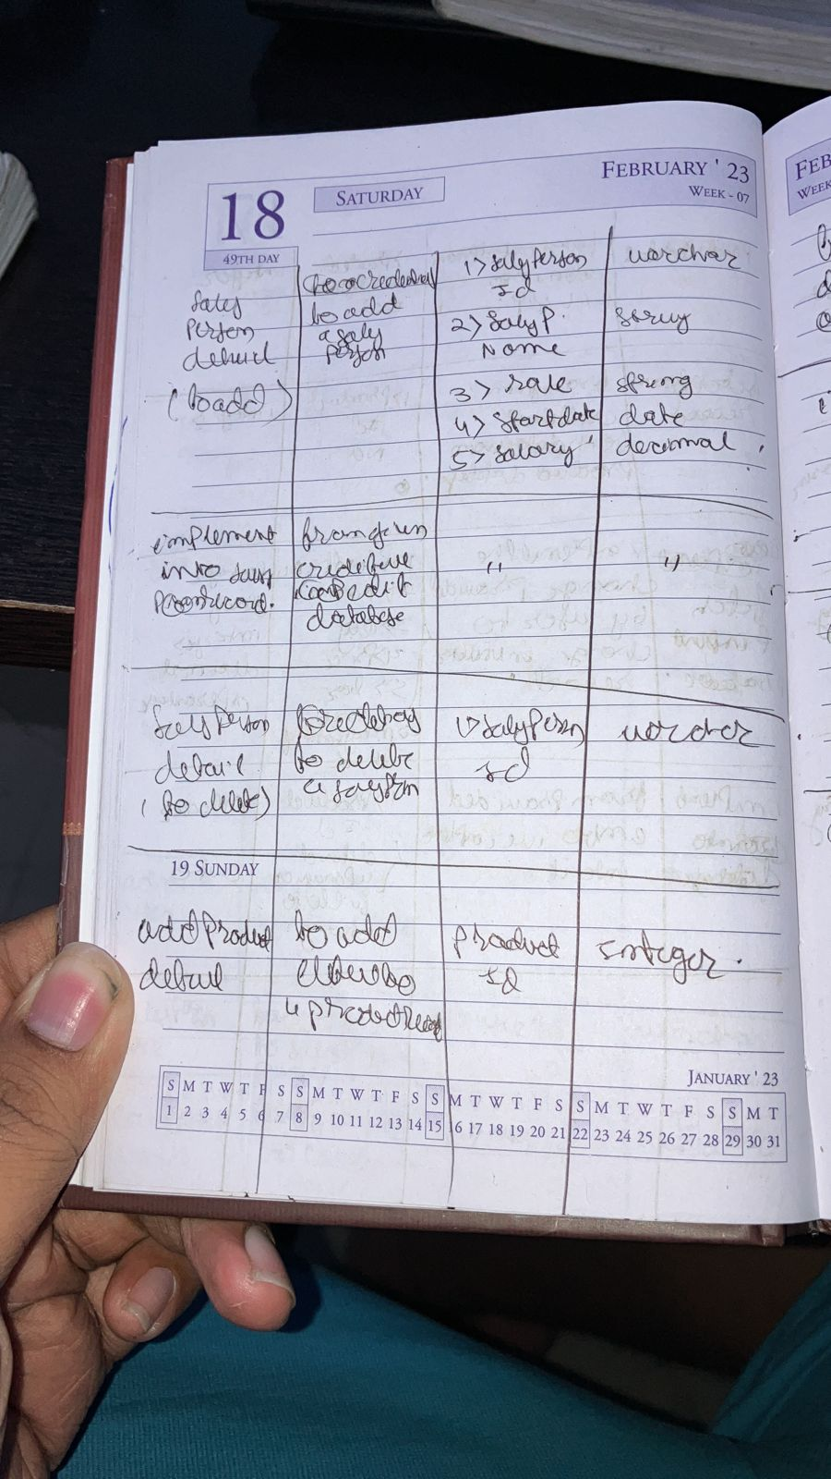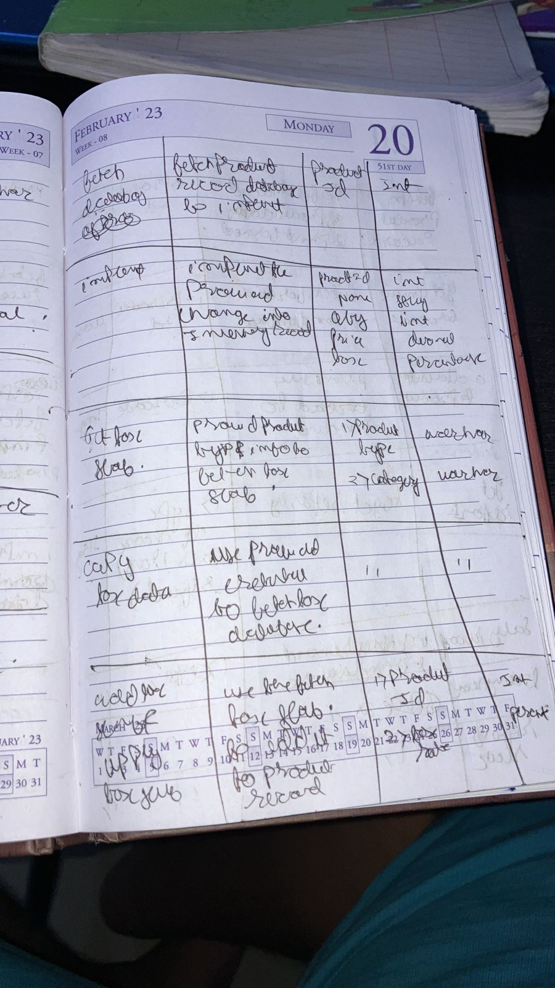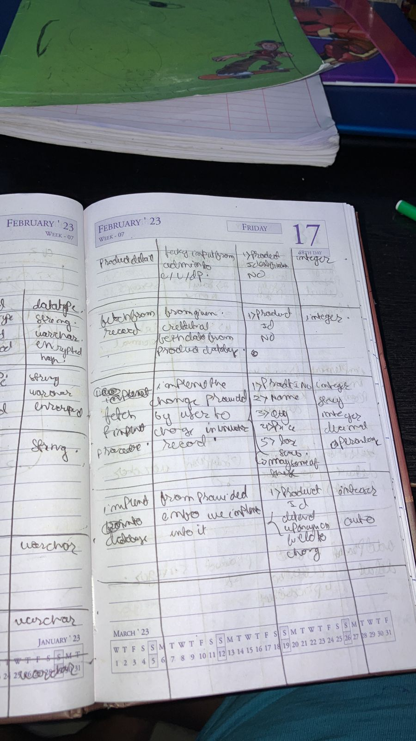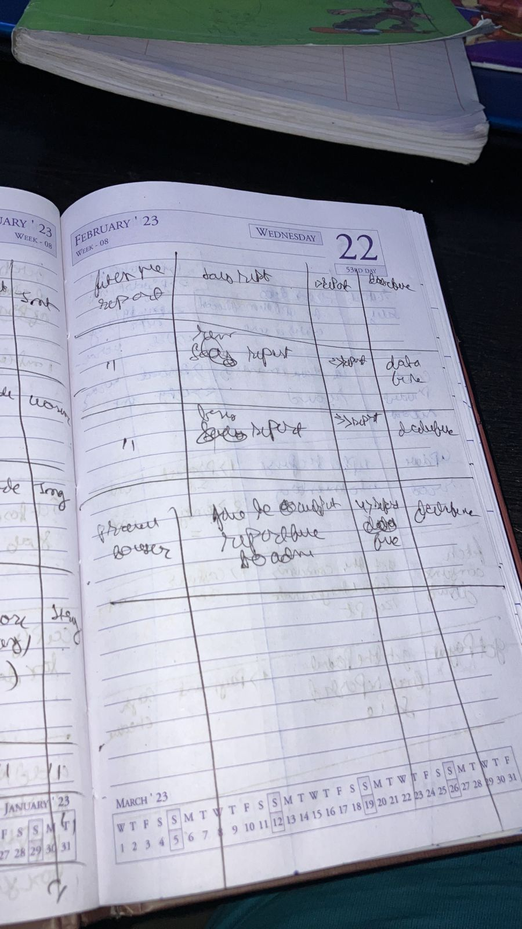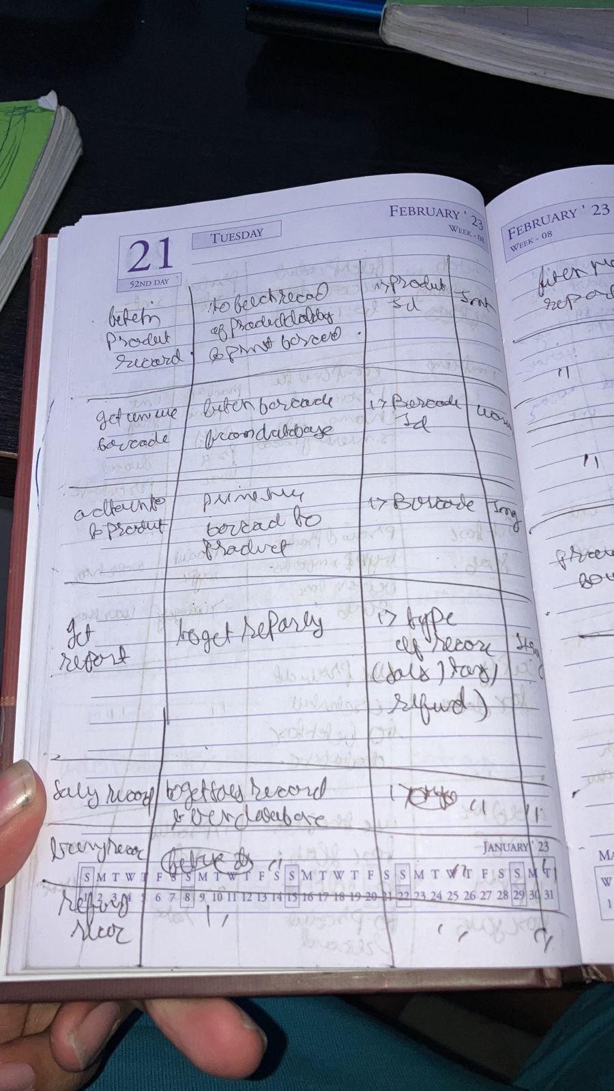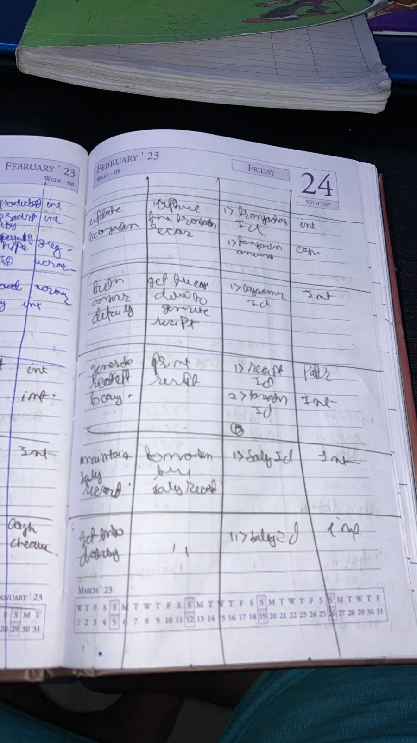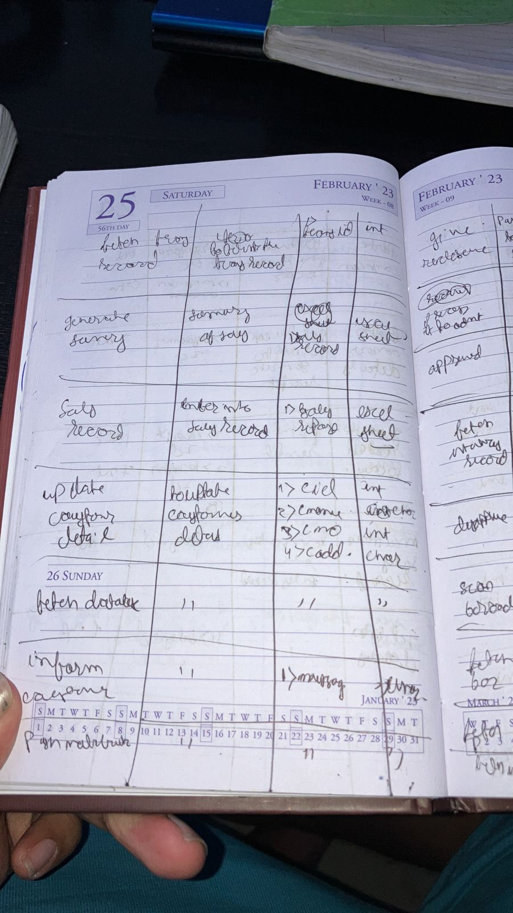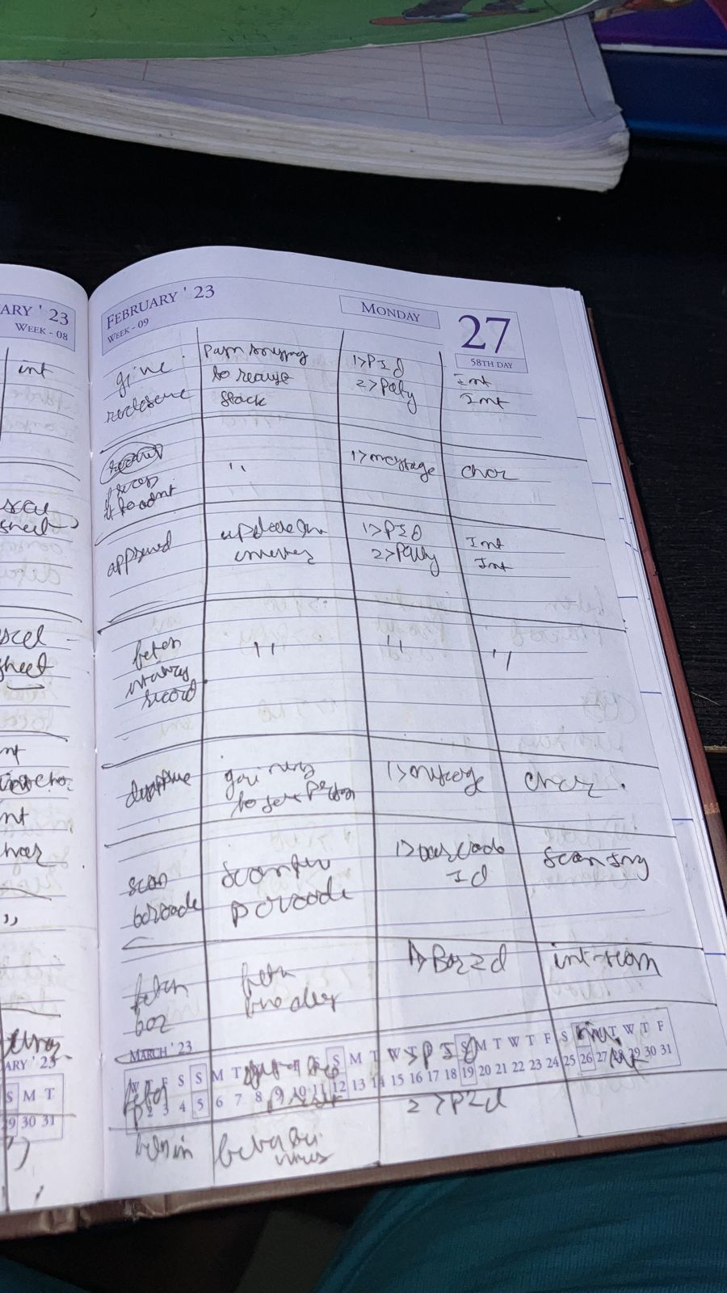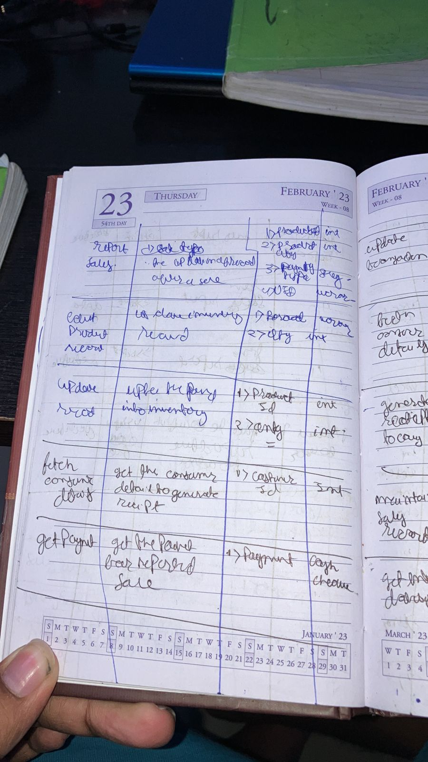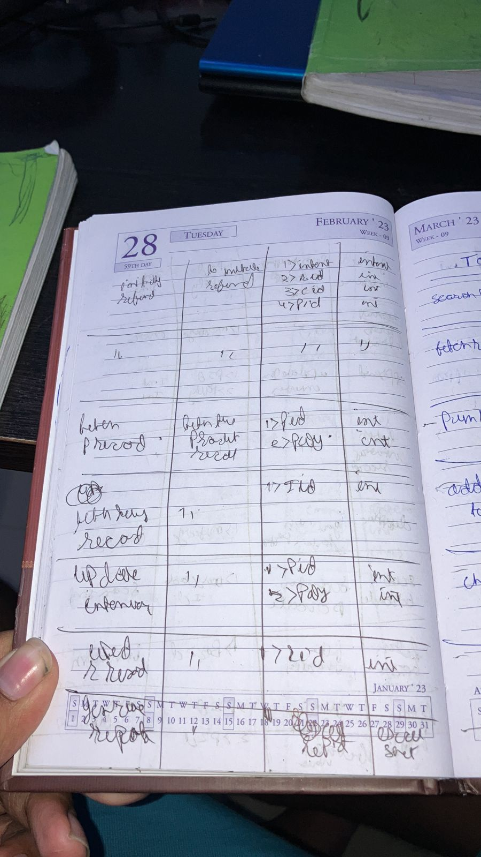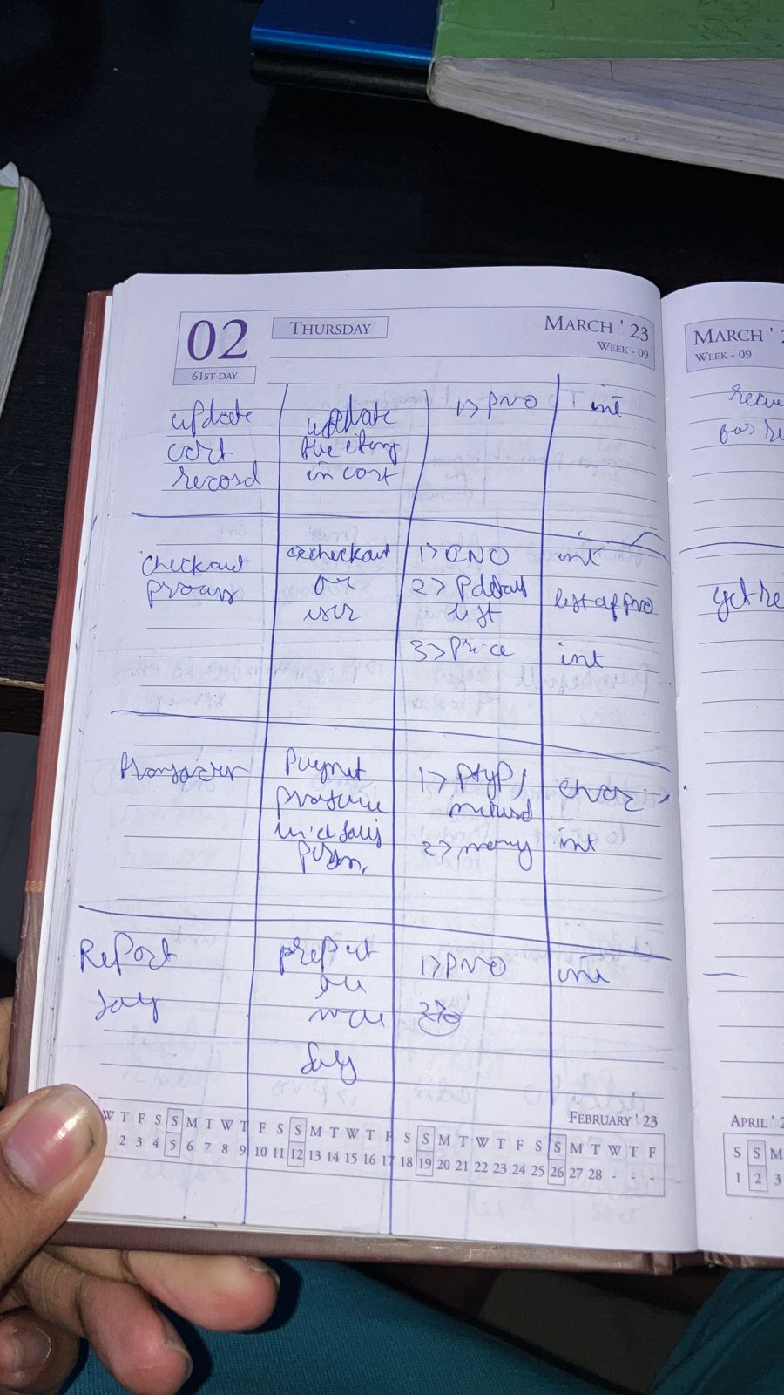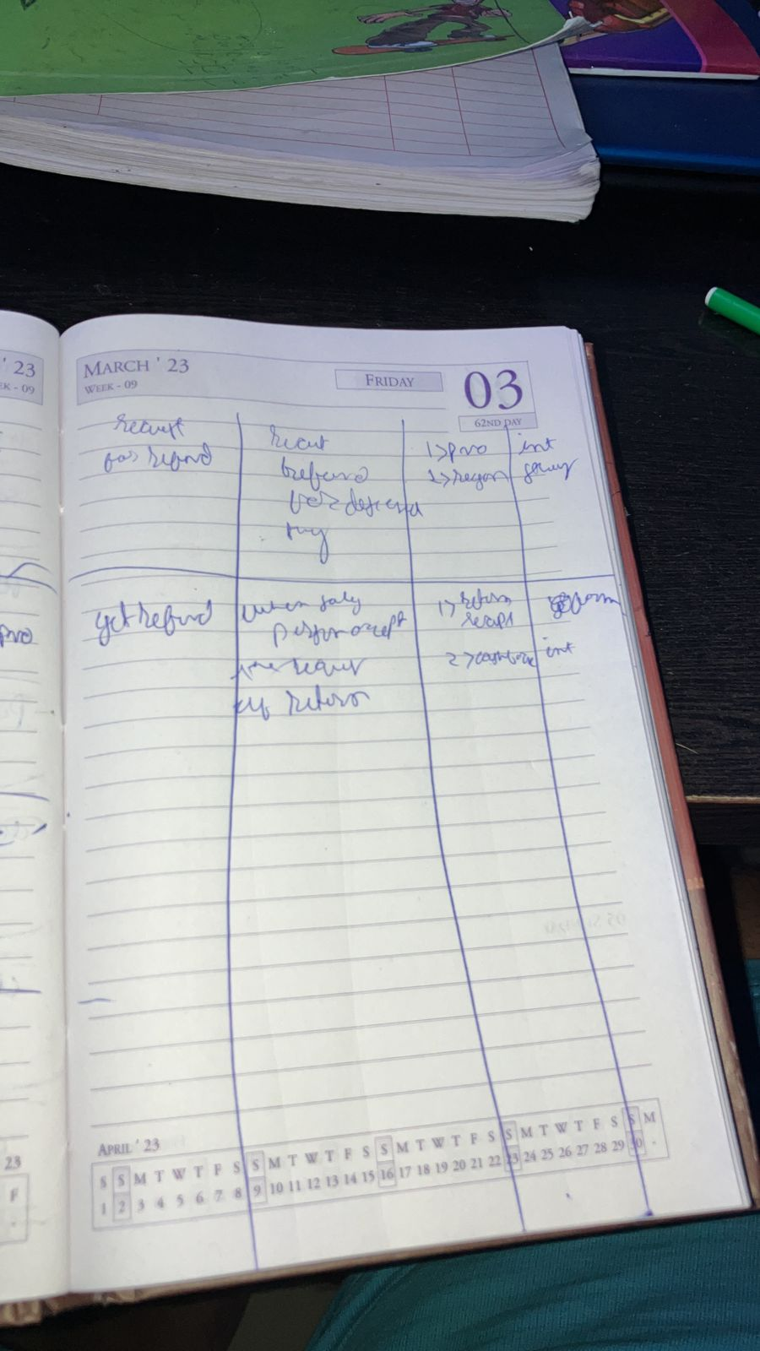

4.3: erd diagrams

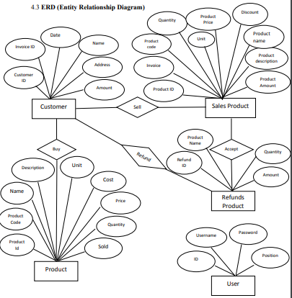

An entity-relationship (ER) diagram is a graphical representation of the entities and the relationships between them in a given information system. It is widely used in computing to organize and visualize data within databases or information systems. An entity refers to a specific object or concept for which data is stored. Each entity has attributes, which describe the characteristics of the entity, such as a customer's name or address. The relationships between entities depict how they are connected or related to each other, such as a customer placing an order for a product. ER diagrams help to accurately represent the real-world objects and concepts that the information system is intended to model, and ensure that their relationships are properly defined. This, in turn, ensures that the resulting database is efficient, scalable, and easy to maintain. Therefore, ER diagrams are an essential tool in the database design process.

4.4 Size estimation :- Functional point analysis

Criteria –

Subfields >3 🡪 difficult

2<=Subfifelds<=3🡪 avg

Subfileds <2🡪simple

Total no of inpurts

Simple 6

Avg 2

Difficult5

Total no of outputs

Simple 11

Avg 8

Difficult5

Total no of iquiries

Simple 1

Avg 4

Difficult 0

Total no of ilf

Simple 13

Avg 6

Difficult4

Total no of elf

Simple 0

Avg 0

Difficult 0

Ufp

=3x6+4x2+6x5+4x11+5x8+7x5+3x1+4x4+0x6+7x13+10x6+15x4+0+0+0

=405

Caf

All complexity adjusent factors would of avg complexity

Caf=(3x0.01x14)+0.35

=1.07

Functionall points=ufpxcaf

=1.07x405

=433

4.5 cost estimation

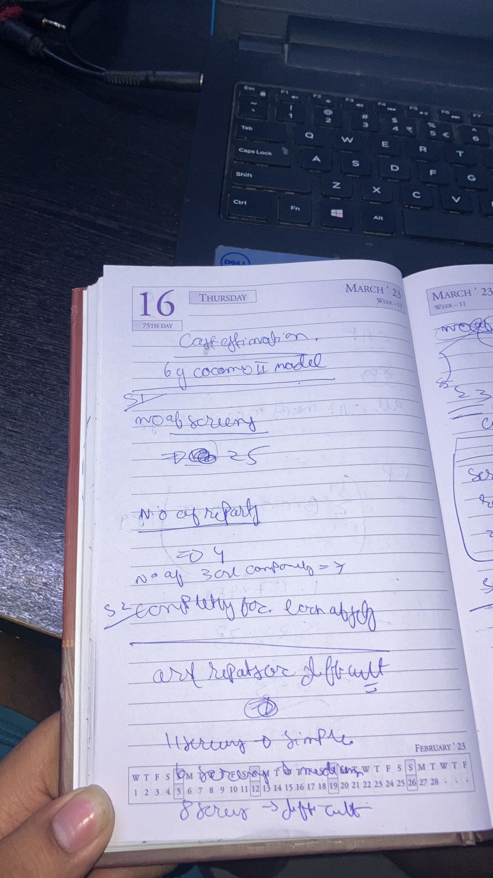

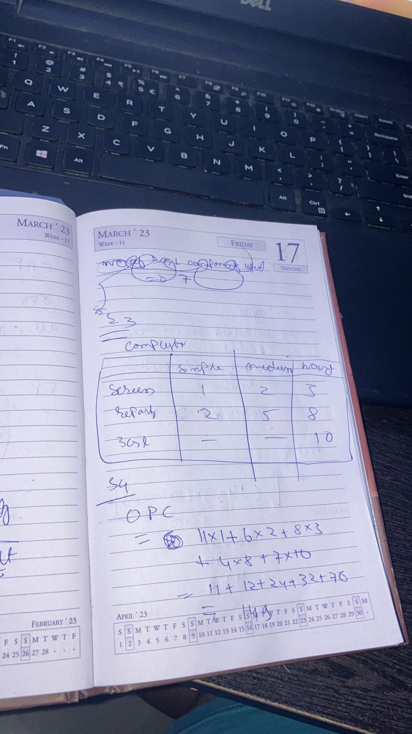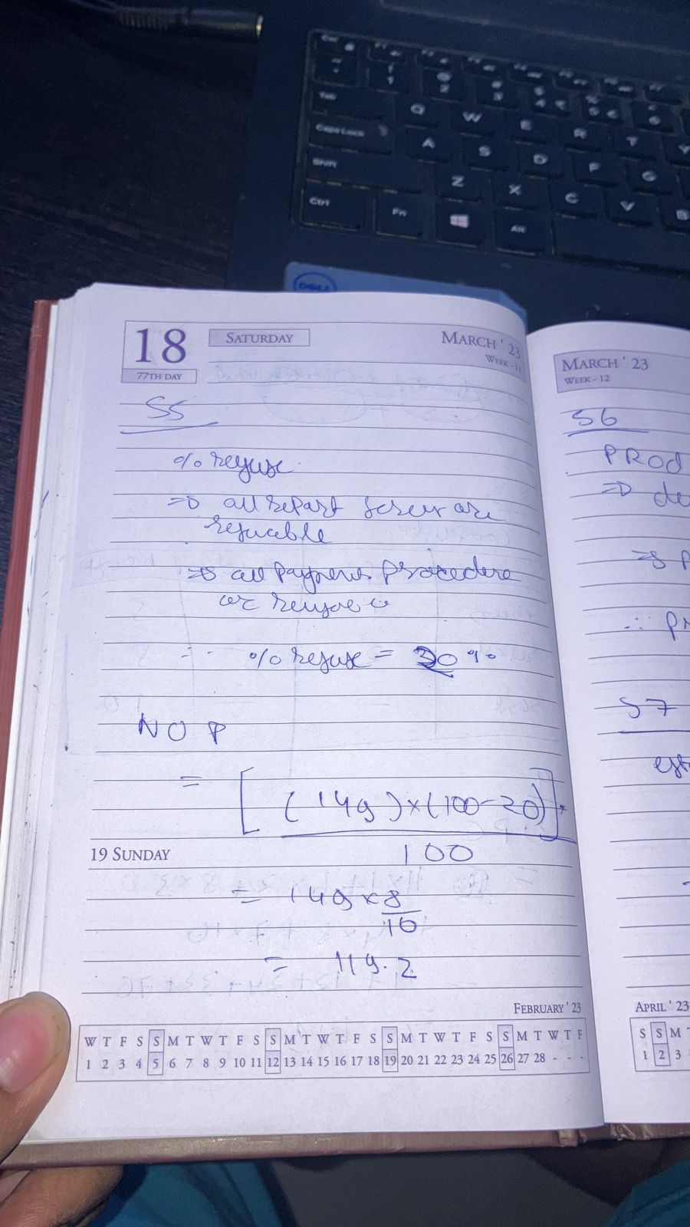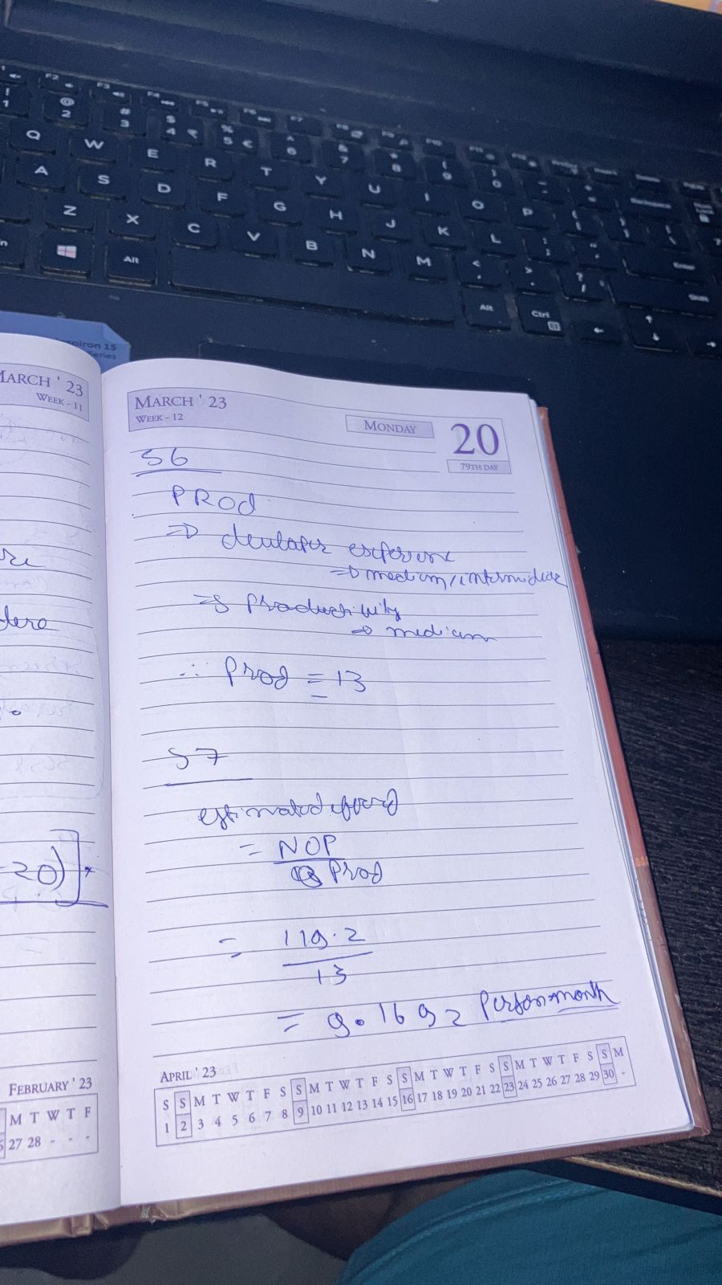

4.6 Web page Design

Web design encompasses many different skills and disciplines in the production and maintenance of websites. The different areas of web design include web graphic design; interface design; authoring, including standardized code and proprietary software; user experience design; and search engine optimization. Often many individuals will work in teams covering different aspects of the design process, although some designers will cover them all. The term web design is normally used to describe the design process relating to the front-end design of a website including writing mark up. Web design partially overlaps web engineering in the broader scope of web development. Web designers are expected to have an awareness of usability and if their role involves creating markup then they are also expected to be up to date with web accessibility guidelines

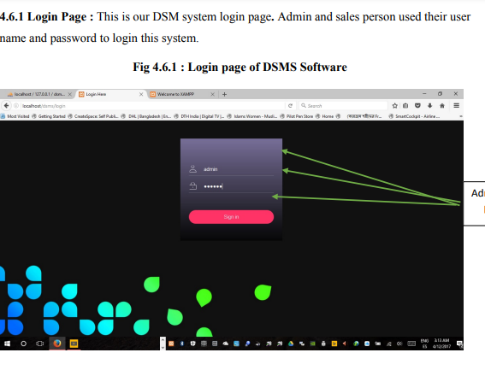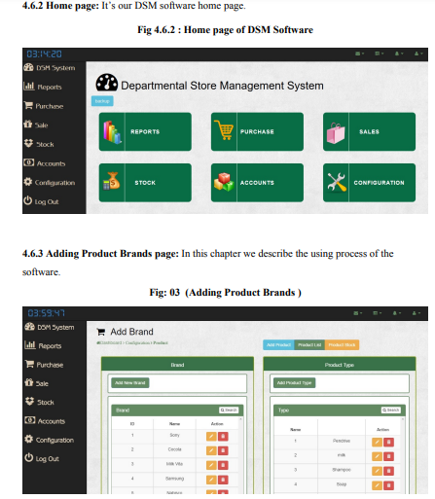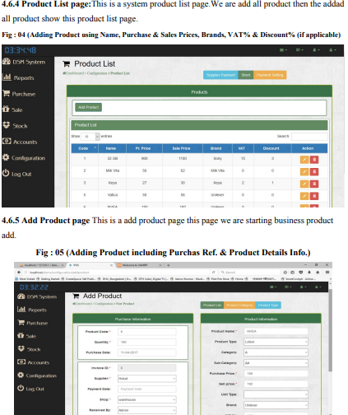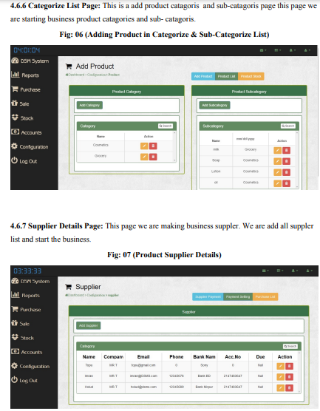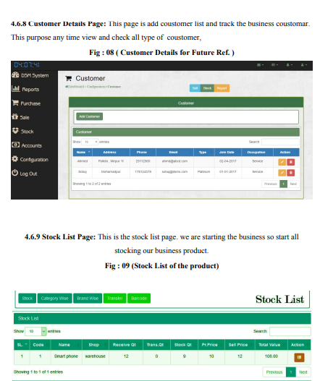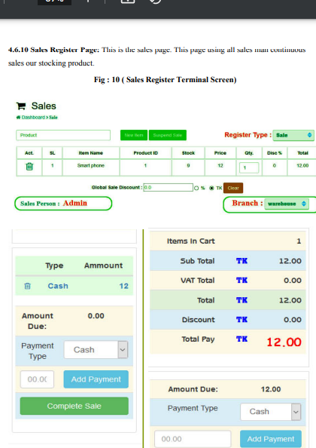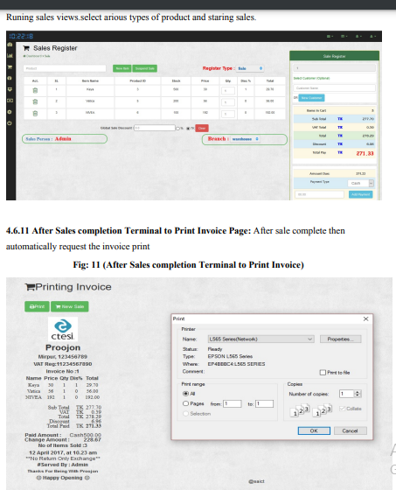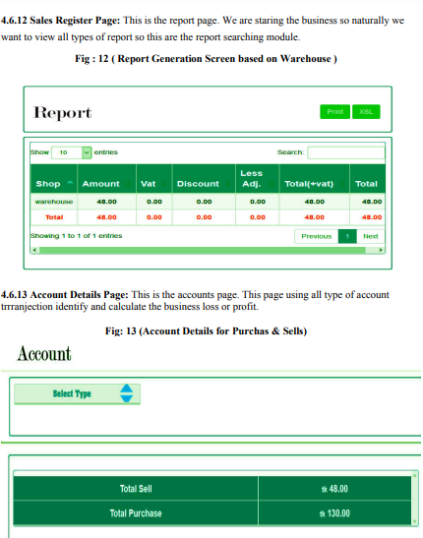

4.7 Gantt Chart

Gantt charts illustrate the start and finish dates of the terminal elements and summary elements of a project. Terminal elements and summary elements comprise the work breakdown structure of the project. Modern Gantt charts also show the dependency (i.e., precedence network) relationships between activities. Gantt charts can be used to show current schedule status using percent-complete shadings and a vertical "TODAY" line as shown here.

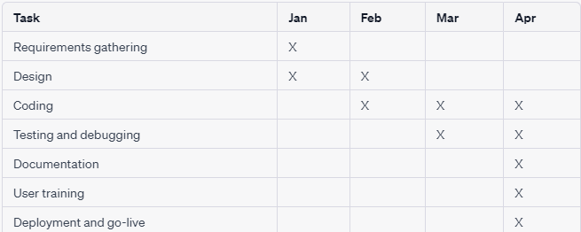

This chart shows the various tasks involved in the development of the software and the months in which they are scheduled to be completed. The "X" marks indicate when a particular task is expected to be completed.

In this schedule, the requirements gathering and design phases are completed in January and February, respectively. Coding takes place throughout February, March, and April, with testing and debugging taking place in March and April. Documentation is scheduled for completion in April, as is user training. Finally, deployment and go-live are also scheduled for April.

4.8 Risk management

Introduction The Departmental Store Management System is a complex software application that involves multiple stakeholders and processes. As with any software development project, it is essential to identify and manage potential risks to ensure the success of the project. In this three-page essay, we will discuss the various risks that may arise during the development process of the Departmental Store Management System and the risk management plan that can be implemented to mitigate these risks.

Potential Risks in Departmental Store Management System Development

1. Scope Creep Scope creep is a common risk that occurs when the project's scope starts to expand beyond the initial requirements. This can lead to delays, increased costs, and a project that does not meet the stakeholders' needs. To mitigate this risk, the project team must establish a clear scope and requirements document that outlines the project's goals, objectives, and deliverables. The scope document should be regularly reviewed and updated, and any changes should be thoroughly assessed and approved by all stakeholders.

2. Security Risks As the Departmental Store Management System deals with sensitive data such as sales, inventory, and financial information, security risks such as data breaches and cyber-attacks can occur if proper security measures are not implemented. To mitigate this risk, the project team must implement security protocols such as encryption, secure authentication, and data backups. The team must also regularly test the system's security measures to ensure that they are effective and up-to-date.

3. Technical Risks Technical risks such as software bugs, hardware failures, and compatibility issues can occur during the development process. These risks can lead to delays, increased costs, and an unsatisfactory product. To mitigate this risk, the project team must conduct thorough testing at each stage of the development process, including unit testing, integration testing, and system testing. The team must also ensure that all hardware and software components used in the system are compatible and meet the project's requirements.

4. Resource Risks Resource risks such as a lack of skilled developers, inadequate funding, and limited timeframes can impact the project's success. To mitigate this risk, the project team must ensure that they have access to the necessary resources to complete the project successfully. This may involve hiring additional staff, allocating additional funds, or extending the project timeline.

Risk Management Plan for Departmental Store Management System Development To mitigate the risks outlined above, the project team must implement a risk management plan that includes the following steps:

1. Identify and assess potential risks: The project team must identify potential risks by analyzing the project requirements, technology used, and possible scenarios that may impact the project. The team must also assess the likelihood and impact of each risk to prioritize mitigation efforts.

2. Develop a risk management plan: Based on the assessment, the team can develop a risk management plan that includes specific strategies to mitigate each risk. The plan must include clear action items, timelines, and responsible parties for each risk mitigation strategy.

3. Implement the risk management plan: The team can implement the risk management plan by executing the strategies identified in the plan. This may involve conducting regular testing, implementing security protocols, updating the scope document, or allocating additional resources.

4. Monitor and review the risk management plan: The team should monitor and review the risk management plan regularly to ensure that it is effective and update it if necessary. The plan must be flexible enough to adapt to changing circumstances or emerging risks.

Conclusion Risk management is a critical aspect of software development, particularly for complex applications such as the Departmental Store Management System. By identifying potential risks and implementing a risk management plan, the project team can minimize the impact of risks on the project's success. The risk management plan should be an integral part

Chapter 5 :DEVELOPMENT AND IMPLEMENTATION

Software development is the process of computer programming, documentation, testing,

and bug fixes related to building and maintaining applications and frameworks, resulting in a

software product. Software development is the process of writing and maintaining source code,

but in a wider sense it includes all that is included between the conception of the desired

software until the final execution of the software, sometimes in the planned and

structured process. Implementation is the realization of an application or the realization of a plan,

an idea, model, proposal, specification, standard, algorithm or policy.

5.1 Project overview

A department store management system created for a department store has the following stages

* Admin/seller login
* Add products, sell products, return products
* Car discount, VAT per product
* Barcode generation, Barcode scanner

Admin/Dealer Login: DSM software can login to both administrator and vendor.

The admin who logged in before. The administrator for the management of the entire DSM system and the seal of persons sells

products.

Add Products/Sell Products/Refund Products: Seller adds a product, sells a product, and

also accept refund products.

Auto Discount, Product VAT: Customer must pay % VAT to buy products and get discounts

some products.

Barcode Generation, Barcode Reader: Admin generate barcodes and scan the seller's product

bar codes.

5.2 DSMS (Departmental Store Management System) terminal.

The Department of Store Management (DSM) system terminal is computerized

cash register replacement. Much more complex than checkouts, if only by a few

years ago, a DSM system may include the ability to record and track customer orders, process

credit and debit cards, connecting to other systems on the network and managing inventory. In general, a

The core of the DSM terminal is a personal computer equipped with a specific application

programs and I/O devices for the specific environment in which it will serve. The DSM system

for example, a restaurant will likely have all menu items stored in a database that may be

asked for information in many ways. DSM terminals are used in most industries

have a department store management system such as a service desk, including restaurants,

accommodation, entertainment and museums.

5.3 Project outputs:

Project outputs are project outputs that typically provide a benefit

change. Outputs can be process improvements, new or improved products and services,

improving service quality, image and reputation artifacts, risk reduction benefits, increasing up to

employee flexibility or efficiency or policy compliance. Deliveries can be for both

within the business and external customers as internal improvements need to be made

cost savings that enable customers to deliver products on time and on budget.

5. 4 Resource Allocation:

In software planning, resource allocation is a plan for using available resources, for

for example, human resources, especially in the near future, to achieve future goals. It is

the process of allocating resources among different projects or business units.

There are two parts to the plan, first there is the basic allocation decision and second

are contingency mechanisms. The basic allocation decision is the selection of items to finance

in the plan and what level of funding it should receive and which should be left unfunded:

resources are allocated to some items and not to others.

Chapter 6 : conclusion and summary

In conclusion, it is clear that there is a need for online DSM software for mini malls to improve their transaction process and payment reporting. Many malls in the country still use the computer-based DSM software, which can cause problems. Therefore, the development of DSM system online software will not only improve the system but also develop the country.

The project planning and implementation process should be sequential and efficient, with a logical business model. Point-of-sale systems are an integral part of today's commercial workplace, and it is important to narrow down the many options available to find the best DSM system for a particular user. Shopping on platforms like Agora gives you the ability to narrow down your selection to find the options you need and buy from sellers around the world.

References used in this project include Ian Somerville's works on project planning, software implementation and testing, as well as PHP and MySQL (version: 5) written by Md. Mijanur Rahman. Other links include Shopify, Wikipedia, academia.edu, POS.com, and the PHP Reference Book.

Future work may focus on improving the DSM software to provide more advanced features and a better user experience. It can also be beneficial to conduct user testing and get feedback for continuous system improvement. In addition, security measures should be implemented to protect user data and prevent unauthorized access.